APIGEE SEC

# Step one:

Create a new proxy with the same configuration as the past one but this time change the base path!

After you made sure that your API proxy is working and accessible let’s add some security:

## Step two:

Go to developers in the drop down menu and fill your information:

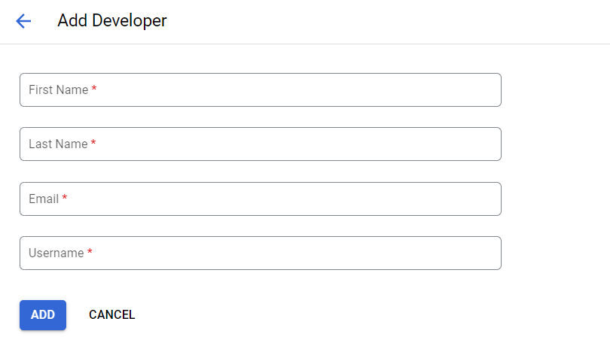

## Step three:

Go to API products and set your quota which is the number of requests until access is blocked:

**You can customize here as you like!**

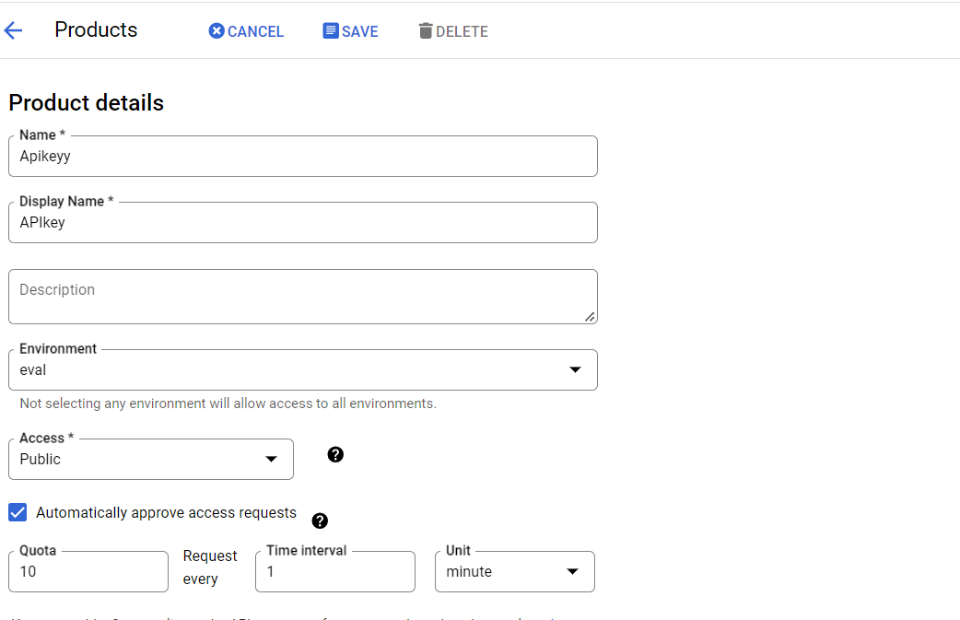

## Step 4:

Go to apps and create a new app:

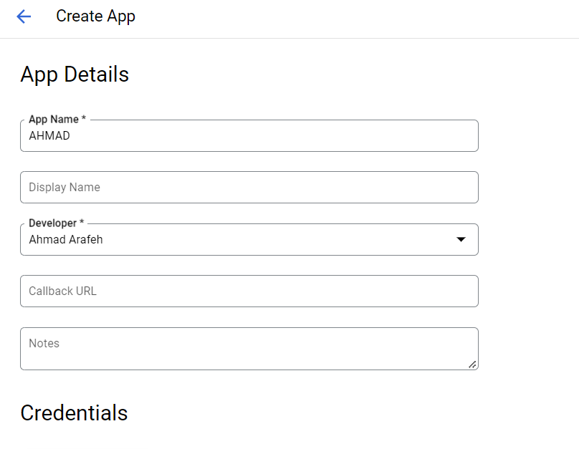

Then add credentials which will be the API key:

## Step 5:

Attach the API key, switch to classic view and press on add step then add the API key:

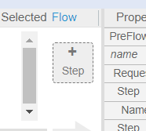

Then press on these apikey and quota:

After that when you go to the link it will ask you for an API key:

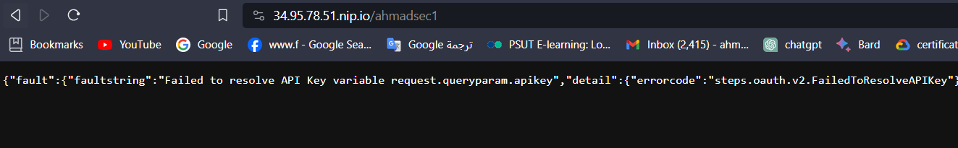

so get it from the apps tab and copy it as a pram in the URL:

Finally paste it and test the quota:

Simple and stupid